“Slaw” by Michelle Willms, published in Scrivener Creative Review, Issue 41, 2016

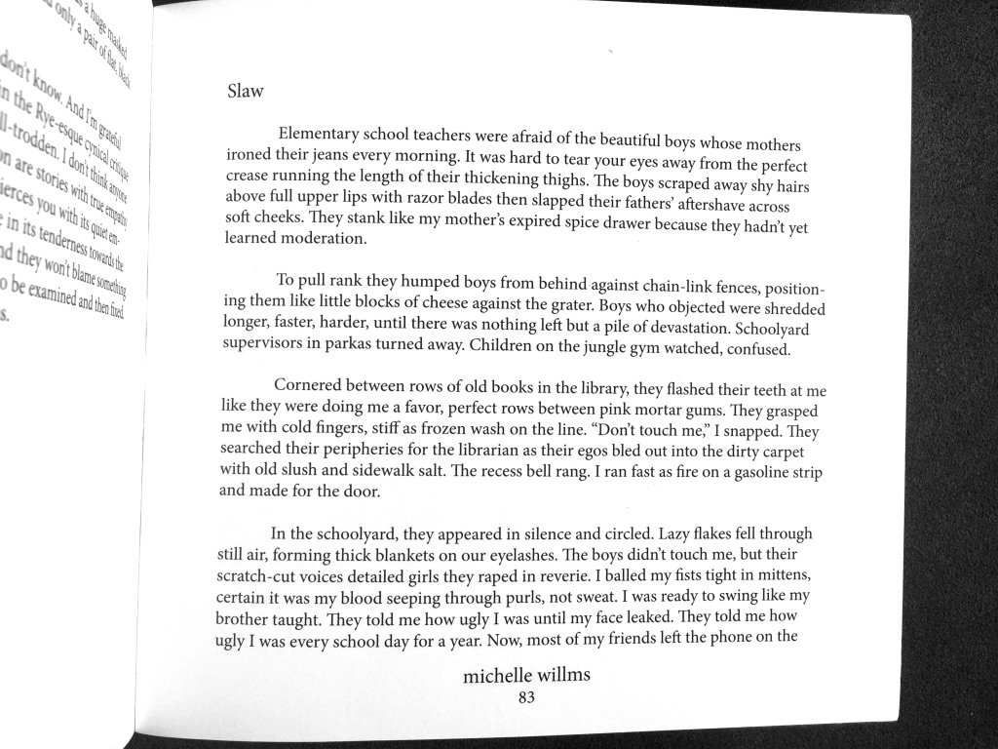

Continued on the next page.
